
August 1, 2016
You must complete your renewal by
September 3, 2016.
Return Service Requested

<FirstName><LastName>
<Address1>
<Address2>
<City>, <State> <Zip>

Dear <FirstName>,
Our 2017 season is another great season! It is such an honor for us at CenterPoint Legacy Theatre to bring you a variety of theatrical experiences. From the classics to newer works destined to become classics, we strive to create an experience that engages, entertains and enriches you each time you come to Our Community’s Theatre.

As a Flex Pass Subscriber you now have the opportunity to renew for the 2017 Season. To do so, you must renew between now and September 3rd.

How to renew:

ONLINE- Visit CPTUtah.org

Simply click on the Season Ticket Renewal link and enter your Order Number and Renewal Code from the attached invoice

VISIT US – Stop by or call the box office
801.298.1302

Wait times on the phone may be longer than normal due to increased calls for renewals

MAIL/FAX –.
Fax - 801.298.4784
PO Box 62 Centerville, UT 84014

Send us the attached invoice with your payment information
Or
Or

If you would like to change your 2017 subscription to a Traditional Subscription, please contact the box office to complete your renewal.

Please address all other renewal questions to the box office staff.

Thank you for your past support of CenterPoint Legacy Theatre as a Season Subscriber. We look forward to having you join us again for our 2017 Season!

With warm regards,
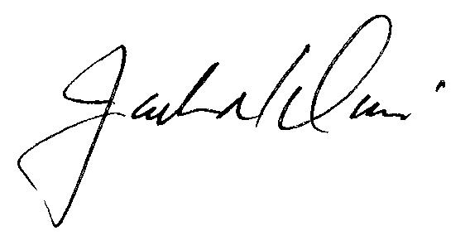
Executive Director
CenterPoint Legacy Theatre

Exchanges: After you have renewed your current subscription, you will have an opportunity to make adjustments or change to a Traditional Season Subscription starting September 12th. However, you must renew by September 3rd for this opportunity.

 | Shipping Information | Billing Information
 | Mary Smith  110 West Ocean Blvd  Long Beach, CA 90802 | Mary Smith  110 West Ocean Blvd.  Long Beach, CA 90802

Order Number: 12345678 | Renewal Code: 73950538124375

Series 2B Sample Organization Subscription 08-09 Saturday 4pm at Sample Venue on 9/28/2008 at 4:00 PM
Delivery Method: First Class Mail (a)

 | Section | Row | Seat | Type | Price | Amount
 | CENTER | B | 106 | Adult | $42.00 | $42.00
 | CENTER | B | 107 | Youth (2-14) | $27.00 | $27.00
 | CENTER | B | 108 | Youth (2-14) | $27.00 | $27.00
 | CENTER | B | 109 | Youth (2-14) | $27.00 | $27.00
 | Processing Fee |  |  |  |  | $5.00
 | Total |  |  |  |  | $388.00

Make checks payable to CenterPoint Legacy Theatre
I prefer to pay by: [ ] MasterCard [ ] Visa [ ] American Express [ ] Discover
_____ _____ _____ _____ - _____ _____ _____ _____ - _____ _____ _____ _____ - _____ _____ _____ _____
(Card Number)
_________________ | ___________________________________ | ___________________________________
(Expiration Date) | (Name as it appears on card) PRINT | (Signature)
SEASON SUBSCRIPTION. Flexible when your schedule isn’t!

Flex Subscription Pricing
Adult $124.00
Senior/Student $112.00

